 **Practice Sheet-4**

**Operating System (Linux)**

**CST108**

**Q.1** When several processes access the same data concurrently and the outcome of the execution depends on the particular order in which the access takes place, what is it called? Also give an example.

**Q.2** Discuss software synchronization tools for critical section problem.

**Q.3** Discuss two process solution.

**Q.4** Discuss semaphore and its types.

**Q.5** Assume that there are 5 processes, P0 through P4, and 4 types of resources. At T0 we have the following system state:

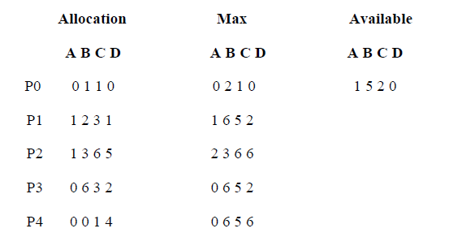

1. Create the need matrix

2. Use the safety algorithm to test if the system is in a safe state.

3. If the system is in a safe state, can the following requests be granted, why or why not? Please also run the safety algorithm on each request as necessary.

a. P1 requests (2,1,1,0)

b. P1 requests (0,2,1,0)

**Q.6** Draw the resource allocation graph for the following data. Is the system deadlocked?

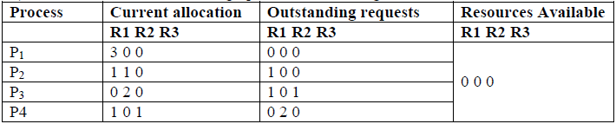

**Q.7** Is the following state safe or unsafe?

